# Department of Computing

**CS-344: Web Engineering**

**Class: BESE-9AB**

# Lab 11: Advanced Angular

**Date: December 24, 2020**

**Time: 10:00-13:00 & 14:00-17:00**

# Instructor: Dr. Qaiser Riaz

# 

# Ahmed Hassan Ismail – BESE98 – 237897

# Lab 11: Advanced Angular 9

### Introduction:

AngularJS is an MVC (or MVV) based JavaScript framework which is widely used to develop single page web applications. The students have already covered the following concepts: components, services, modules, pipes, directives, form handling. This lab will help them to further understand these concepts by developing example applications.

### Lab Objectives:

The objective of this lab is helping students to familiarize themselves with advanced usage of Angular in developing single page web applications. Students will develop small applications using Angular 9 according to the given scenarios. The knowledge students have gained in the lectures will help them to control dynamic behavior of web pages.

### Tools:

Notepad, DreamWeaver, browser.

### Helping Material:

Lecture slides.

W3Schools: <https://www.w3schools.com/angular/default.asp>

jQuery Cheatsheet: <https://dncmagazine.blob.core.windows.net/downloads/AngularCheatSheet-DNCMagazine.pdf>

### Lab Task

### Task 1

By now you have become familiar with Angular. In this lab, we will be using **Jsonplaceholder API**. **JSONPlaceholder** is a free online REST **API** that you can use whenever you need some fake data. It supports all HTTP methods like Get, Post, Put and Delete. Click [here](https://jsonplaceholder.typicode.com) to learn more.

Your task is to create a photo album which will fetch all the albums from jsonplaceholder api. Use proper routing to handle HTTP routes like Get, Post, Put and Delete photos.

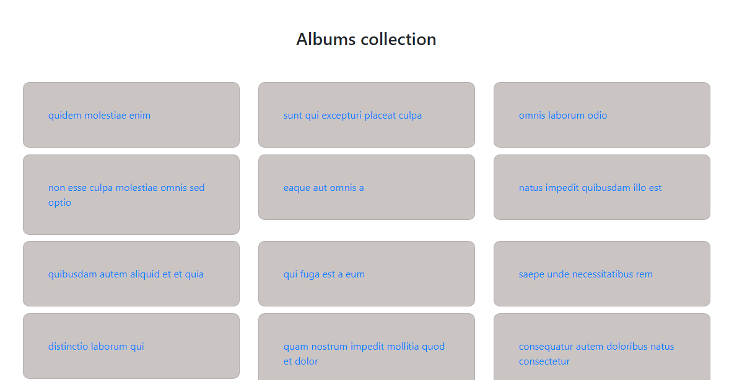

When an album is clicked, all its respective images should be loaded.

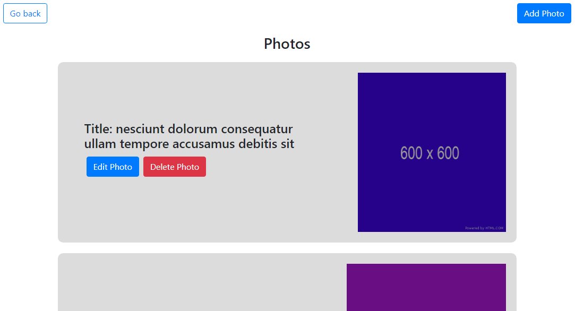

You should set proper routes for routing between pages. When add photo button is clicked, a form should appear which contains two input fields i.e. title and URL of the photo.

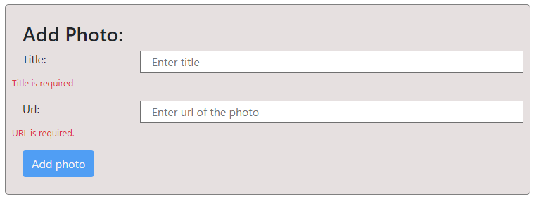

These fields are marked as required. Use angular reactiveforms to handle form validation.

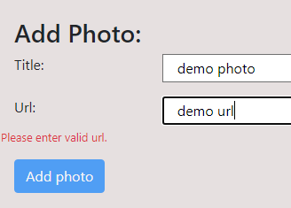

Your task is to check whether the entered URL is valid or not. If not, add photo button should be non-functional.

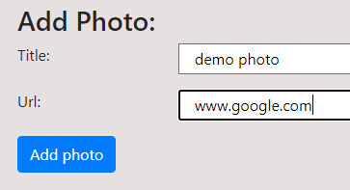

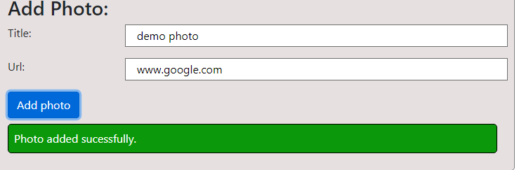

When a valid name and URL is entered, the photo button should become functional and when clicked, should submit the form. Keep in mind that jsonplaceholder API is a fake API which only provides data for HTTP get operations. You cannot create, update, or delete any data on this API. To check whether the add operation is successful, open developer tools and go to **Network** tab. When you perform add operation, a file will be created below. Click on it to see the details.

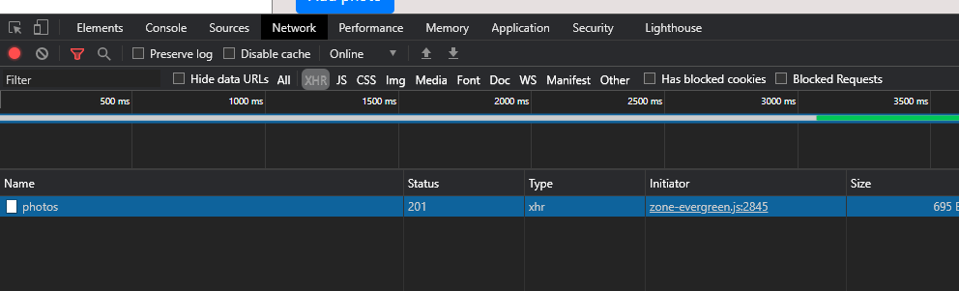

When you click on photo, you should see details of this.

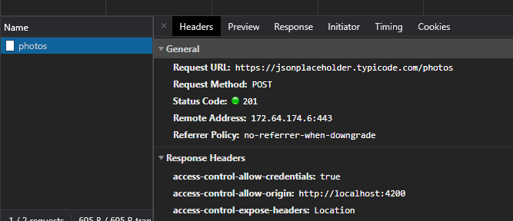

Notice that when add operation was performed, a status code of 201 was returned which means that POST operation was successful. This will not post the photo to original API, but you get confirmation that request method was successfully done.

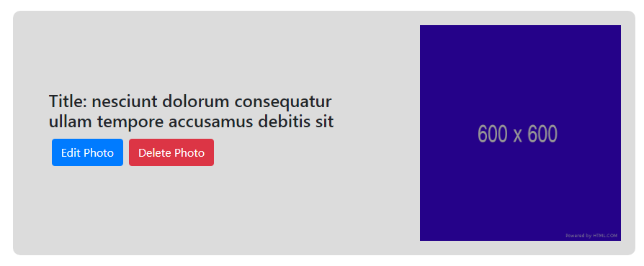

When you click on edit button, a new form should appear which will have same input fields as add photo form had. You should perform input validation to ensure valid title and URL is entered.

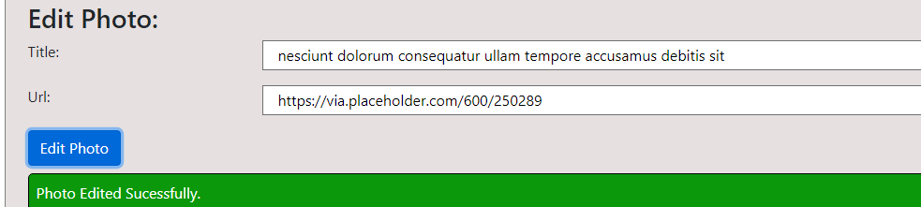

Once the edit operation is done, head over to developer tools and perform the same steps to check if operation was successful or not.

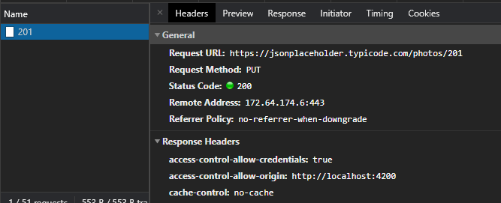

The delete button should pass the id of the photo in delete method.

`https://jsonplaceholder.typicode.com/photos/${*photo*.id}`

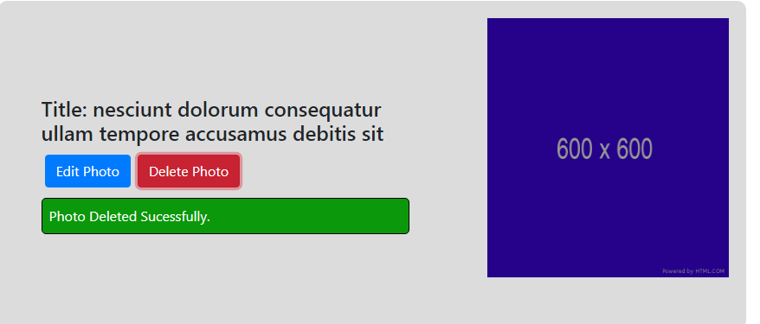

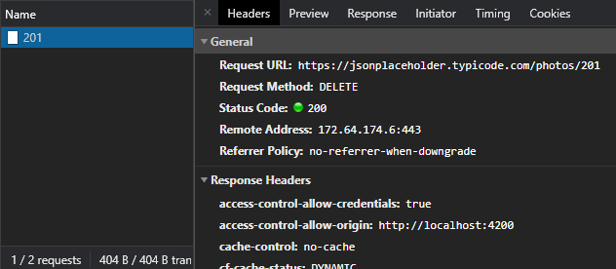

**Note: Upload complete solutions of the task in in a single zip file along with code and screenshots of your solutions in this word file.**

**Also Upload screenshot of the developer tools window for every operation.**

|  |
| --- |
| Solution |
| Task 1:  Solution is available in .zip file, I did not include node_modules folder in the angular project folder.  Task 1 screenshot: |

### Deliverables

Compile a single word document by filling in the solution part and submit this Word file on LMS. You must include your name, ID, and class on first page. The lab grading policy is as follows: The lab is graded between 0 to 10 marks. For some of the labs, students must present their solutions in a viva session. In case of any problems with submissions on LMS, you should contact your lab engineer Mr. Aftab Hussain by email at [Aftab.hussain1@seecs.edu.pk](mailto:Aftab.hussain1@seecs.edu.pk).